

**Applied Excel (STA432)**

Summary Report

Name: Jeevan Koshy

Register No: 1740256

Class: 4CMS

**TABLE OF CONTENTS**

|  |  |  |  |
| --- | --- | --- | --- |
| **SL NO** | **NAME** | **No. of sheets** | **Start date** |
| 1 | Sorting_56 | 5 | 26 ‎November ‎2018, ‏‎22:05:24 |
| 2 | BasicLab_56 | 5 | 20 ‎November ‎2018, ‏‎10:30:29 |
| 3 | HouseDesign-4,43,56 | 3 | 28 ‎November ‎2018, ‏‎10:08:32 |
| 4 | Functions_56 | 4 | ‎4 ‎December ‎2018, ‏‎09:57:32 |
| 5 | TOC_56 | 3 | 5 ‎December ‎2018, ‏‎12:44:43 |
| 6 | LookUp_56 | 1 | 12 ‎December ‎2018, ‏‎12:08:44 |
| 7 | Thinking_56 | 2 | 18 ‎December ‎2018, ‏‎09:38:34 |
| 8 | Analysis_56 | 3 | 1 ‎January ‎2019, ‏‎20:45:19 |
| 9 | DBDesign_56 | 2 | 9 ‎January ‎2019, ‏‎12:20:19 |
| 10 | Filter_56 | 5 | 31 ‎January ‎2019, ‏‎11:18:48 |
| 11 | GanttChart_56 | 1 | 26 ‎February ‎2019, ‏‎09:14:51 |
| 12 | SQL_56 | 1 | 27 ‎February ‎2019, ‏‎12:29:35 |

**SORTING** [Sorting_56]

This sheet was given to us for homework. I had done sorting techniques such as Bubble sort, selection sort, insertion sort and merge sort.

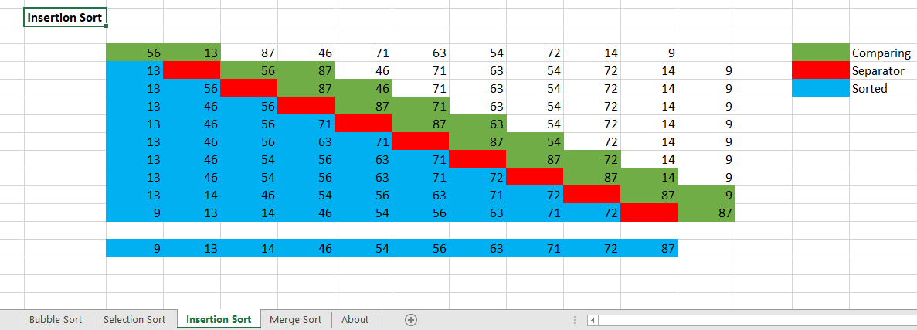

**BASIC LAB** [BasicLab_56]

This workbook was created on 20th November, 2018. One of the 1st few workbooks that we have made in class. Other sheets: SmartArt, Graph, Functions.

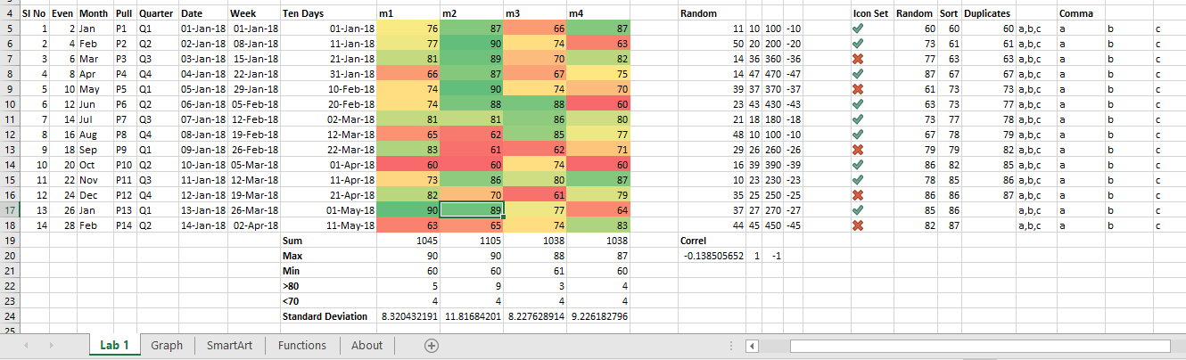I have used functions like text to columns, date, month, day, conditional formatting and more. The workbook contains 5 sheets.

**HOUSE DESIGN** [HouseDesign-4,43,56]

The house design excel sheet was created on 28th November, 2018.

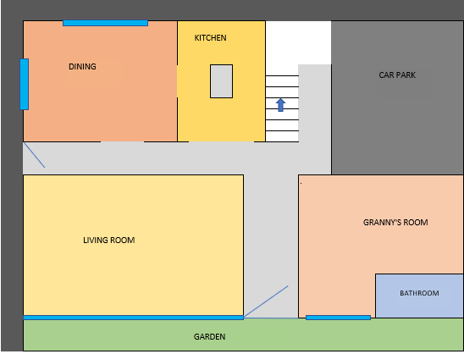

There were actually 2 floors that we made. The above screenshot is the ground floor that we designed using Excel.

**FUNCTIONS** [Functions_56]

The functions worksheet was created on 4th December, 2018. This sheet was mainly to explore all the functions in excel such as the text functions, data & time, mathematical etc.

There were around 30 functions which I had used in this workbook.

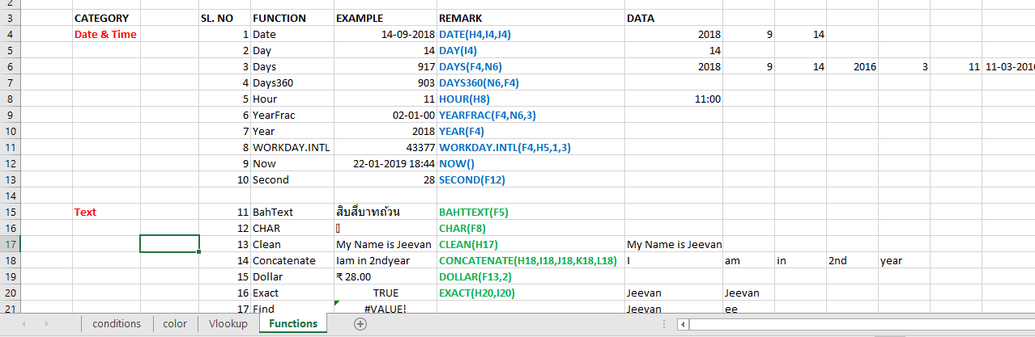

**Table of Contents** [TOC_Jeevan Koshy]

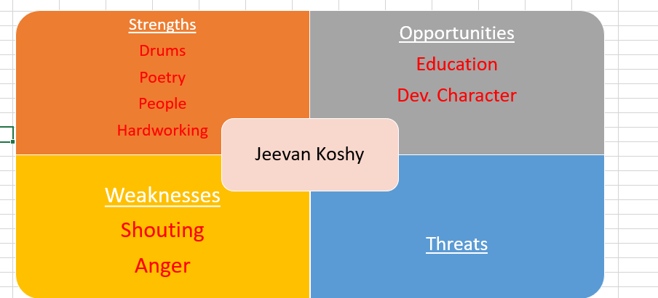

This sheet was created on 5th December, 2018. There is a happiness graph showing the happiness level over the years and a TOC sheet with a summary of all the sheets done in excel.

**LOOKUP** [LookUp_56]

This sheet was created on 12th ‎December ‎2018. Using the formula of VLOOKUP, we learnt how values can be accessed from another table and put in a new table.

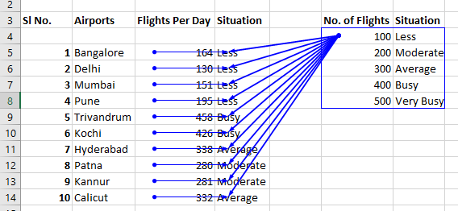

The blue lines traces the dependence of the values from the table used to lookup.

**Thinking** [Thinking_56]

Sheet created on 18th December 2019. Contains a few graphs based on input values for different functions.

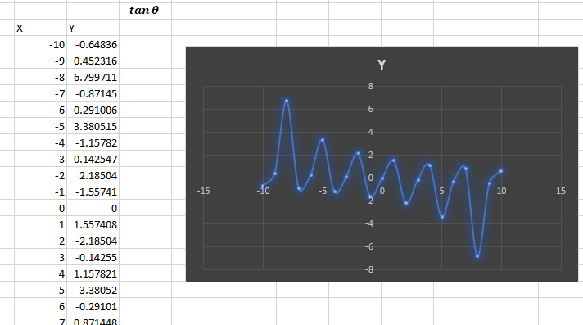

**Homework Assignment 1** [Analysis_56]

This sheet was created on 1st January, 2019. It was a homework assignment where we had had to analyse any data of our choice in Excel. This was the first sheet created in the new year, 2019.

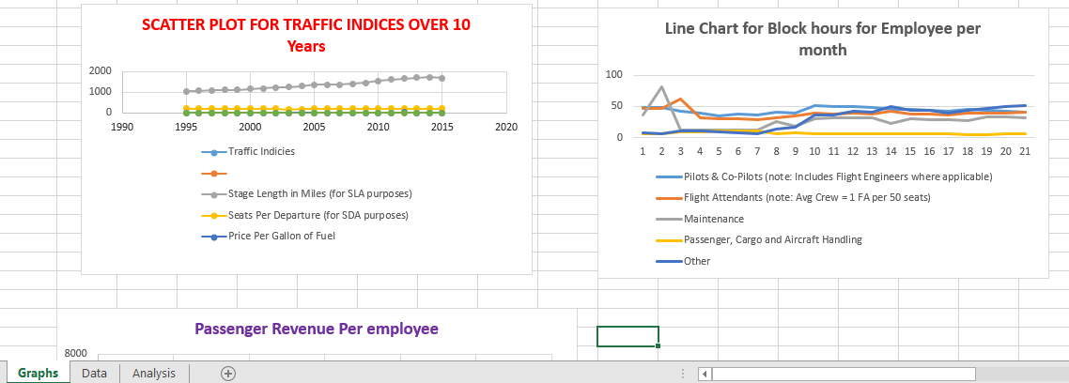

**DATABASE DESIGN** [DBDesign_56]

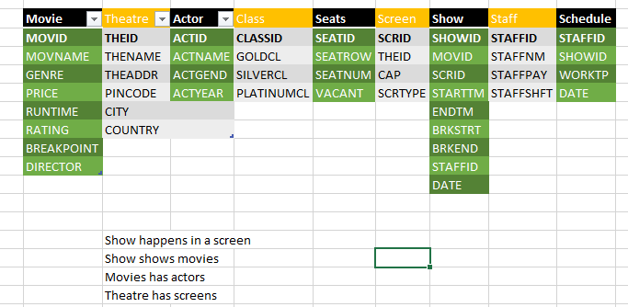

This sheet was created on 9th ‎January ‎2019. Some values are dependent on each other while creating a database. One should know everything related to each field before implementing a database on that topic because of the number of factors that go in creating it.

**FILTER** [Filter_56]

This sheet was created on 31st ‎January ‎2019. I had used functions like sort & filter, pivot table.

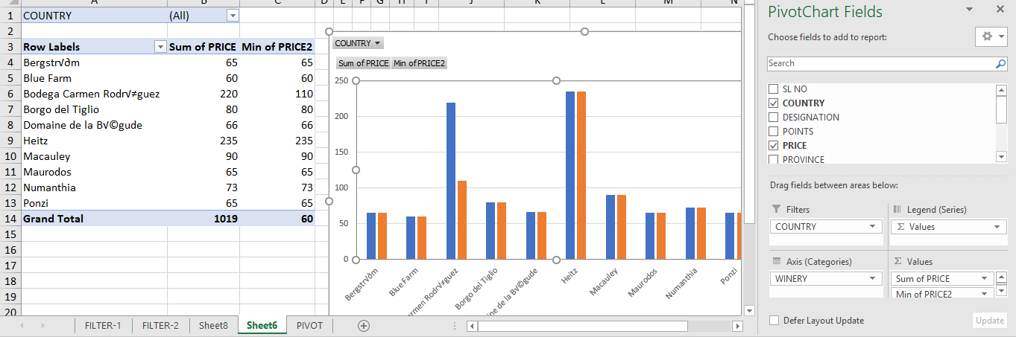

**Gantt Chart** [GanttChart_56]

This sheet was created on 26th ‎February ‎2019. It was made to predict the time to start making a sambhar given a deadline of 6:00pm. I included the amount of time making each ingredient would take and putting all that together – the sambhar would be ready by 6:00pm.

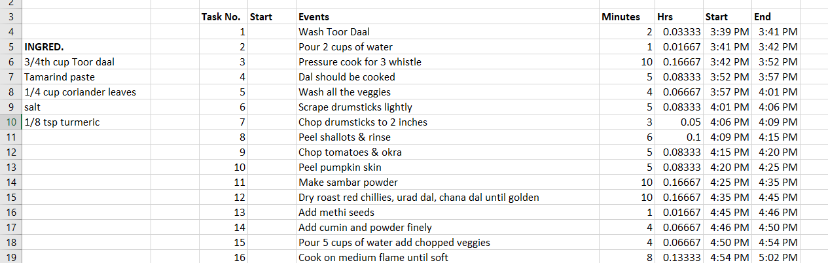

**SQL** [SQL_56]

A sheet with a bunch of queries. Sheet Created on 27th February, 2019.



